**Revenue**

| **Year(X)** | **Revenue(Y)** | **X-X̅** | **Y-Y̅** | **(X-X̅)(Y-Y̅)** | **(X-X̅)²** | **(Y-Y̅)²** |
| --- | --- | --- | --- | --- | --- | --- |
| **2020** | **24996056** | 2 | 8702010.8 | 17404021.6 | 4 | 7.57E+13 |
| **2019** | **20156447** | 1 | 3862401.8 | 3862401.8 | 1 | 1.49E+13 |
| **2018** | **15794341** | 0 | -499704.2 | 0 | 0 | 2.50E+11 |
| **2017** | **11692713** | -1 | -4601332.2 | 4601332.2 | 1 | 2.12E+13 |
| **2016** | **8830669** | -2 | -7463376.2 | 14926752.4 | 4 | 5.57E+13 |
| **X̅** =2018 | **Y̅**=16294045.2 | **∑(X-X̅)**=0 | **∑(Y-Y̅)**=0 | **∑(X-X̅)(Y-Y̅)**=40794508 | **∑(X-X̅)²**= 10 | **∑(Y-Y̅)²**=1.678E+14 |

**Karl Pearson Coefficient of Correlation :**

**r =** 0.9959747282 Hence it is a Positive correlation

**Variance of X : VX** = 2

**Standard Deviation of X: SX** =1.414213562

**Variance of Y : VY** = 33553417246588

**Standard Deviation of Y: SY** = 5792531.161

**Linear Regression Function: Y= a+bx**

**b = r* (SY/Sx**) =4079450.801

**a = Y̅ - bX̅ =** -8216037672

**Y=** -8216037672**+**4079450.801**x**

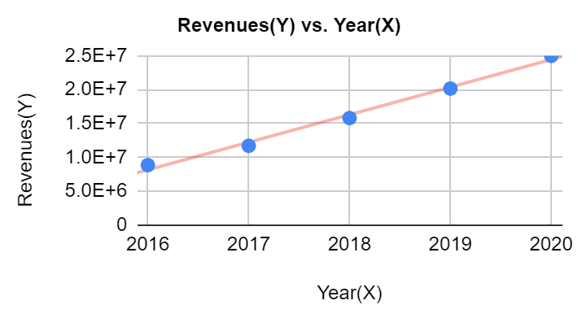**Forecasted Value of REVENUE for the next 5 years**

| **Year** | **Revenue(1000$)** |
| --- | --- |
| 2021 | 28532396.82 |
| 2022 | 32611847.62 |
| 2023 | 36691298.42 |
| 2024 | 40770749.22 |
| 2025 | 44850200.02 |

**Cost of Revenue**

| **Year(X)** | **Cost of revenue(Y)** | **X-X̅** | **Y-Y̅** | **(X-X̅)(Y-Y̅)** | **(X-X̅)²** | **(Y-Y̅)²** |
| --- | --- | --- | --- | --- | --- | --- |
| **2020** | **-15276319** | 2 | -5001591.6 | -10003183.2 | 4 | 2.50E+13 |
| **2019** | **-12440213** | 1 | -2165485.6 | -2165485.6 | 1 | 4.69E+12 |
| **2018** | **-9967538** | 0 | 307189.4 | 0 | 0 | 9.44E+10 |
| **2017** | **-7659666** | -1 | 2615061.4 | -2615061.4 | 1 | 6.84E+12 |
| **2016** | **-6029901** | -2 | 4244826.4 | -8489652.8 | 4 | 1.80E+13 |
| **X̅** =2018 | **Y̅**=-10274727.4 | **∑(X-X̅)**=0 | **∑(Y-Y̅)**=0 | **∑(X-X̅)(Y-Y̅)** =-23273383 | **∑(X-X̅)²**= 10 | **∑(Y-Y̅)²**=5.466E+13 |

**Karl Pearson Coefficient of Correlation :**

**r =** -0.9954920068 Hence it is a Negative correlation

**Variance of X : VX** = 2

**Standard Deviation of X: SX** =1.414213562

**Variance of Y : VY** = 10931341807275

**Standard Deviation of Y:**  **SY** = 3306257.977

**Linear Regression Function: Y= a+bx**

**b = r* (SY/Sx**) = -2327338.301

**a = Y̅ - bX̅ =**4686293964

**Y=**  4686293964 **+** -2327338.301**x**

**Forecasted Value of COST OF REVENUE for the 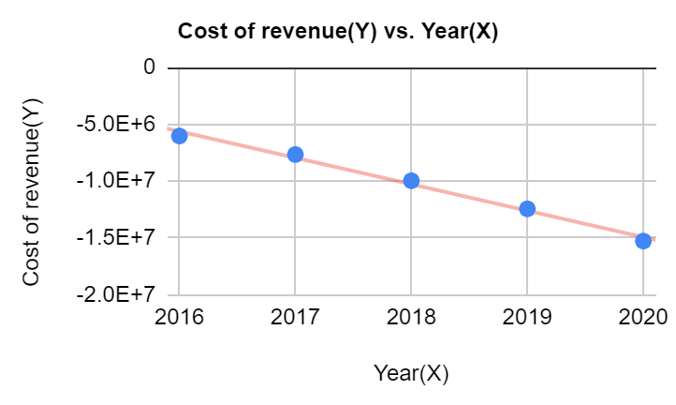next 5 years**

| **Year** | **Cost of Revenue(1000$)** |
| --- | --- |
| 2021 | -17256742.32 |
| 2022 | -19584080.62 |
| 2023 | -21911418.92 |
| 2024 | -24238757.22 |
| 2025 | -26566095.52 |

**Gross Profit**

| **Year(X)** | **Gross profit(Y)** | **X-X̅** | **Y-Y̅** | **(X-X̅)(Y-Y̅)** | **(X-X̅)²** | **(Y-Y̅)²** |
| --- | --- | --- | --- | --- | --- | --- |
| **2020** | **9719737** | 2 | 3700419.2 | 7400838.4 | 4 | 1.37E+13 |
| **2019** | **7716234** | 1 | 1696916.2 | 1696916.2 | 1 | 2.88E+12 |
| **2018** | **5826803** | 0 | -192514.8 | 0 | 0 | 3.71E+10 |
| **2017** | **4033047** | -1 | -1986270.8 | 1986270.8 | 1 | 3.95E+12 |
| **2016** | **2800768** | -2 | -3218549.8 | 6437099.6 | 4 | 1.04E+13 |
| **X̅ =**2018 | **Y̅=6019317.8** | **∑(X-X̅)**=0 | **∑(Y-Y̅)**=0 | **∑(X-X̅)(Y-Y̅)**=17521125 | **∑(X-X̅)²**= 10 | **∑(Y-Y̅)²**=3.091E+13 |

**Karl Pearson Coefficient of Correlation :**

**r =** 0.9965158783 Hence it is a Positive correlation

**Variance of X : VX** = 2

**Standard Deviation of X: SX** =1.414213562

**Variance of Y : VY** = 6182804659957

**Standard Deviation of Y:**   **SY** = 2486524.615

**Linear Regression Function: Y= a+bx**

**b = r* (SY/Sx**) = 1752112.59

**a = Y̅ - bX̅ =** -3529743709

**Y=** -3529743709 **+** 1752112.59**x**

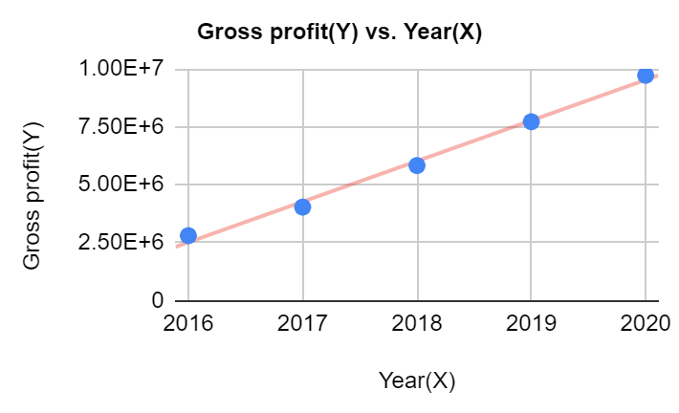**Forecasted Value of GROSS PROFIT for the next 5 years**

| **Year** | **Gross Profit(1000$)** |
| --- | --- |
| 2021 | 11275655.52 |
| 2022 | 13027768.02 |
| 2023 | 14779880.52 |
| 2024 | 16531993.02 |
| 2025 | 18284105.53 |

**Operating Income**

| **Year(X)** | **Operating income(Y)** | **X-X̅** | **Y-Y̅** | **(X-X̅)(Y-Y̅)** | **(X-X̅)²** | **(Y-Y̅)²** |
| --- | --- | --- | --- | --- | --- | --- |
| **2020** | **4585289** | 2 | 2582640.8 | 5165281.6 | 4 | 6.67E+12 |
| **2019** | **2604254** | 1 | 601605.8 | 601605.8 | 1 | 3.62E+11 |
| **2018** | **1605226** | 0 | -397422.2 | 0 | 0 | 1.58E+11 |
| **2017** | **838679** | -1 | -1163969.2 | 1163969.2 | 1 | 1.36E+12 |
| **2016** | **379793** | -2 | -1622855.2 | 3245710.4 | 4 | 2.63E+12 |
| **X̅ =**2018 | **Y̅=2002648.2** | **∑(X-X̅)**=0 | **∑(Y-Y̅)**=0 | **∑(X-X̅)(Y-Y̅)**=10176567 | **∑(X-X̅)²**= 10 | **∑(Y-Y̅)²**=1.118E+13 |

**Karl Pearson Coefficient of Correlation :**

**r =** 0.9625241902 Hence it is a Positive correlation

**Variance of X : VX** = 2

**Standard Deviation of X: SX** =1.414213562

**Variance of Y : VY** = 2235678148837

**Standard Deviation of Y:**   **SY** = 1495218.428

**Linear Regression Function: Y= a+bx**

**b = r* (SY/Sx**) = 1017656.7

**a = Y̅ - bX̅ =** -2051628572

**Y=**  -2051628572 **+** 1017656.7**x**

**Forecasted Value of OPERATING 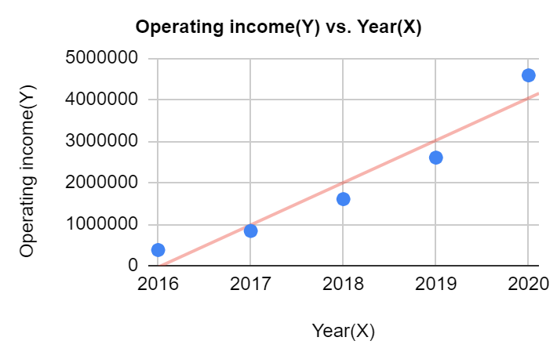INCOME for the next 5 years**

| **Year** | **Operating Income(1000$)** |
| --- | --- |
| 2021 | 5055618.7 |
| 2022 | 6073275.4 |
| 2023 | 7090932.1 |
| 2024 | 8108588.8 |
| 2025 | 9126245.5 |

**Share Price**

| **Year(X)** | **Share price(Y)** | **X-X̅** | **Y-Y̅** | **(X-X̅)(Y-Y̅)** | **(X-X̅)²** | **(Y-Y̅)²** |
| --- | --- | --- | --- | --- | --- | --- |
| **2020** | **446.8272** | 2 | 174.3485 | 348.697 | 4 | 3.04E+04 |
| **2019** | **328.8713** | 1 | 56.3926 | 56.3926 | 1 | 3.18E+03 |
| **2018** | **319.2903** | 0 | 46.8116 | 0 | 0 | 2.19E+03 |
| **2017** | **165.3743** | -1 | -107.1044 | 107.1044 | 1 | 1.15E+04 |
| **2016** | **102.0304** | -2 | -170.4483 | 340.8966 | 4 | 2.91E+04 |
| **X̅ =**2018 | **Y̅=272.4787** | **∑(X-X̅)**=0 | **∑(Y-Y̅)**=0 | **∑(X-X̅)(Y-Y̅)**=853.0906 | **∑(X-X̅)²**= 10 | **∑(Y-Y̅)²**=7.629E+04 |

**Karl Pearson Coefficient of Correlation :**

**r =** 0.9766822727 Hence it is a Positive correlation

**Variance of X : VX** = 2

**Standard Deviation of X: SX** = 1.414213562

**Variance of Y : VY** = 15258.56523

**Standard Deviation of Y:**   **SY** = 123.5255651

**Linear Regression Function: Y= a+bx**

**b = r* (SY/Sx**) = 85.30906003

**a = Y̅ - bX̅ =** -171881.2044

**Y=**  -171881.2044 **+**  85.30906003**x**

**Forecasted Value of SHARE PRICE for the next 5 years**

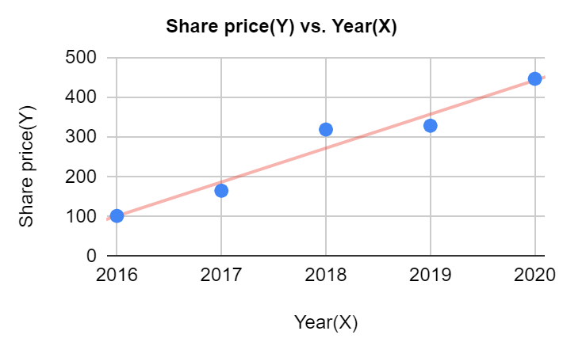

| **Year** | **Share Price($)** |
| --- | --- |
| 2021 | 528.4059206 |
| 2022 | 613.7149807 |
| 2023 | 699.0240407 |
| 2024 | 784.3331007 |
| 2025 | 869.6421607 |

**Coefficient of Variation and Correlation**

| **Data Parameter** | **Mean(1000$)** | **Coefficient of Variation(%)** | **Correlation** |
| --- | --- | --- | --- |
| **Revenue** | 16294045.2 | 35.54998829 | Positive |
| **Cost of Revenue** | -10274727.4 | 32.17854692 | Negative |
| **Operating Income** | 2002648.2 | 74.6620613 | Positive |
| **Gross Profit** | 6019317.8 | 41.30907684 | Positive |
| **Share Price** | 272.4787 | 45.33402615 | Positive |

This table gives us an idea about the coefficient of variation of each parameter in percentage.

The coefficient of variation is defined as the ratio of standard deviation of the population to the population mean Helps us to understand how consistent the data is it is also used in in predicting for Risk factors so that potential or important investment don't lead to loss of the company institution

It is important to note that greater the value of coefficient of variation greater will be the consistency of data parameters..

Correlation between two parameters indicates how strongly the two are linearly related.

Positive correlation indicates that increase or decrease in one parameter corresponds to the increase or decrease in the other parameter respectively. This is also known as direct correlation.

Negative correlation implies that increase or decrease in one parameter response to a decrease or increase in the other parameter. This is also known as indirect correlation

Interest analysis cost of revenue as a negative correlation why all the other data parameters have a positive correlation. This means that the value of year increases the value of cost of revenue decreases, which in turn means that the company is spending less on expenditures yearly.